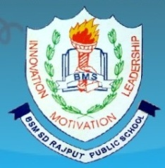
BSMSD RAJPUT PUBLIC SCHOOL Affiliated by C.B.S.E New Delhi vide affiliation no: 1631159 Near bridge No: 04, Jugial Road, Sujanpur Ph: 22433228 Email:bsmsdrajputpublicschool@.com
PARENT TEACHER ASSOCIATION

SR. NO. | NAME | DESIGNATION | Phone No. | ADDRESS | Signature
1 | Ms. Neelam | Principal | 9464134564 | Pathankot
2 | Mr. Anil Pathania | Teacher | 7669950796 | Azizpur
3 | Mrs .Chanchal Devi | Teacher | 9888662668 | Sujanpur
4 | Mr. Rajeshwar Singh | Teacher | 9646874834 | Narot Mehra
5 | Mrs. Kavita | Parent | 7837063216 | Big Bhanwal
6 | Mr. Ajay Jasrotia | Parent | 9988294775 | Sujanpur
7 | Mrs. Sunita | Parent | 9779740653 | Big Bhanwal

This is to certify that the above mentioned members are in the school ‘s PARENT TEACHER ASSOCIATION of BSMSD RAJPUT PUBLIC SCHOOL , SUJANPUR and their tenure, is of three years in normal circumstances . This is future declared that no member has any blood relation with one another.

