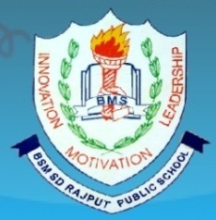
BSMSD RAJPUT PUBLIC SCHOOL Affiliated by C.B.S.E New Delhi vide affiliation no: 1631159 Near bridge No: 04, Jugial Road, Sujanpur Ph: 2243228 Email:bsmsdrajputpublicschool@.com

It is certified that BSMSD Rajput Public has submitted an application for the Extension of affiliation and here by confirmed that all accompanying documents are authentic and have been thoroughly verified to the best of my knowledge.

Principal

